PROGRESSIVE ELECTRICITY BILLING
1.Problem Statement
Design a Python program to calculate household electricity bills using progressive consumption slabs. The program must add fixed charges, apply a surcharge when applicable, apply a rebate when eligible, compare bills for several months, and flag unusual increases. Each slab rate applies only to the units inside that slab.

2. Objectives
Calculate energy charges across multiple usage slabs.
• Add a fixed monthly charge.
• Apply a surcharge when consumption exceeds the defined limit.
• Apply a rebate to eligible bills.
• Store and compare bills across months.
• Flag a bill that is more than 30% above the previous month's bill.
• Display clear, testable results.
3. Assumptions
And Illustrative Tariff All rates below are examples for this academic project. Currency is Indian rupees (■), and consumption is measured in kilowatt-hours (kWh), commonly called units.
Component | Rule used in this project
Slab 1 | 0–100 units: ₹1.50 per unit
Slab 2 | 101–200 units: ₹2.50 per unit
Slab 3 | 201–400 units: ₹4.00 per unit
Slab 4 | Above 400 units: ₹6.00 per unit
Fixed charge | ₹75 per month
Surcharge | 5% of energy charge + fixed charge when consumption is above 300 units
Rebate | 5% of energy charge when consumption is at most 100 units
Unusual increase | Flag if the current bill is more than 30% higher than the previous bill
Rounding | Final bill rounded to two decimal places
Calculation order: Energy charge → Fixed charge → Surcharge, if eligible → Rebate, if eligible → Final bill

4. Algorithm
1. Start.
2. Set slab rates, fixed charge, surcharge rate, rebate rate, and alert threshold.
3. Read each month's name and units consumed.
4. Reject negative consumption.
5. Calculate energy charges slab by slab.
6. Add the fixed charge.
7. If units exceed 300, add a 5% surcharge on energy charge plus fixed charge.
8. If units are at most 100, subtract a rebate equal to 5% of energy charge.
9. Calculate the final bill.
10. Compare each bill with the previous month's bill.
11. Flag increases greater than 30%.
12. Display results and stop
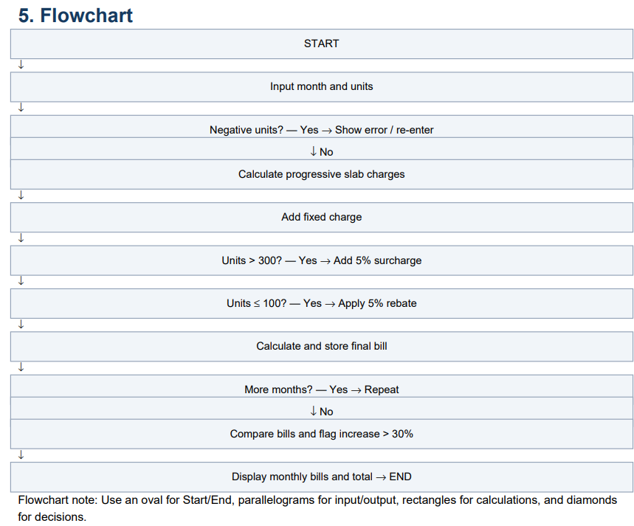

6. Pseudocode
SET fixed_charge = 75
SET unusual_threshold = 30
FUNCTION energy_charge(units):
IF units < 0: RETURN error
energy = MIN(units, 100) * 1.50
IF units > 100:
energy += MIN(units - 100, 100) * 2.50
IF units > 200:
energy += MIN(units - 200, 200) * 4.00
IF units > 400:
energy += (units - 400) * 6.00
RETURN energy
FUNCTION calculate_bill(month, units):
energy = energy_charge(units)
fixed = 75
surcharge = 0
rebate = 0
IF units > 300:
surcharge = 0.05 * (energy + fixed)
IF units <= 100:
rebate = 0.05 * energy
total = energy + fixed + surcharge – rebate
RETURN bill details
FOR each month:
read month and units
calculate and save bill
FOR each bill after the first:
increase = (current - previous) / previous * 100
IF increase > 30: flag unusual
DISPLAY monthly details, alerts, and total

7. Python Source Code
from dataclasses import dataclass
FIXED_CHARGE = 75.00
SURCHARGE_RATE = 0.05
REBATE_RATE = 0.05
UNUSUAL_INCREASE_PERCENT = 30.0
@dataclass
class Bill:
month: str
units: float
energy: float
fixed: float
surcharge: float
rebate: float
total: float
def energy_charge(units):
"""Calculate progressive charges, one slab at a time."""
if units < 0:
raise ValueError("Units cannot be negative.")
charge = min(units, 100) * 1.50
if units > 100:
charge += min(units - 100, 100) * 2.50
if units > 200:
charge += min(units - 200, 200) * 4.00
if units > 400:
charge += (units - 400) * 6.00
return charge
def calculate_bill(month, units):
energy = energy_charge(units)
fixed = FIXED_CHARGE
surcharge = SURCHARGE_RATE * (energy + fixed) if units > 300 else 0.0
rebate = REBATE_RATE * energy if units <= 100 else 0.0
total = round(energy + fixed + surcharge - rebate, 2)
return Bill(month, units, energy, fixed, surcharge, rebate, total)
def main():
# Example data; edit this list to test other months.
monthly_usage = [
("January", 90),
("February", 110),
("March", 180),
("April", 300),
("May", 450),
]
bills = [calculate_bill(month, units) for month, units in monthly_usage] print("PROGRESSIVE ELECTRICITY BILL")
print("-" * 91)
print(f"{'Month':7}{'Energy':>12}"
f"{'Fixed':>10}{'Surcharge':>12}{'Rebate':>10}"
f"{'Bill':>12} Alert")
print("-" * 91)
for i, bill in enumerate(bills):
alert = ""
if i > 0 and bills[i - 1].total > 0:
increase = ((bill.total - bills[i - 1].total)
/ bills[i - 1].total) * 100
if increase > UNUSUAL_INCREASE_PERCENT:
alert = f"Increase {increase:.1f}%"
print(f"{bill.month:7.0f}"
f"{bill.energy:>12.2f} {bill.fixed:>10.2f}”
f"{bill.total:>12.2f} {alert}")
print("-" * 91)
print(f"Total for {len(bills)} months: "
f"Rs. {sum(b.total for b in bills):.2f}")
if __name__ == "__main__":
main()
f"{bill.total:>12.2f} {alert}")
print("-" * 91)
print(f"Total for {len(bills)} months: "
f"Rs. {sum(b.total for b in bills):.2f}")
if __name__ == "__main__":
main()

8.TestCases
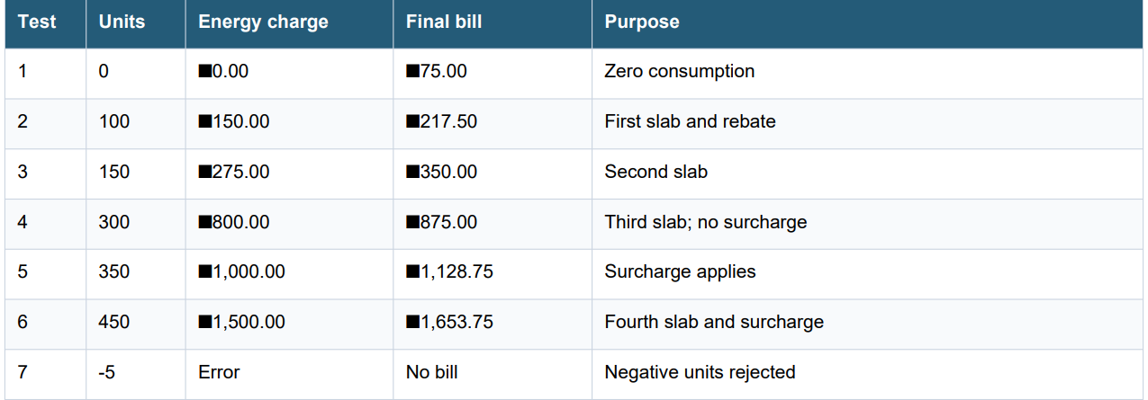
Verification examples
For 150 units: 100 × ■1.50 + 50 × ■2.50 = ■275 energy charge. Add ■75 fixed charge. No surcharge or rebate
applies, so the bill is ■350.00.
For 350 units: ■150 + ■250 + (150 × ■4.00) = ■1,000 energy charge. Add ■75 fixed charge; surcharge = 5% ×
■1,075 = ■53.75. Final bill = ■1,128.75.

9. Sample Output Screen
Text representation of the console output produced by the source code:
PROGRESSIVE ELECTRICITY BILL
-------------------------------------------------------------------------------------------
Month Units Energy Fixed Surcharge Rebate Bill Alert
-------------------------------------------------------------------------------------------
January 90 135.00 75.00 0.00 6.75 203.25
February 110 175.00 75.00 0.00 0.00 250.00
March 180 350.00 75.00 0.00 0.00 425.00 Increase 70.0%
April 300 800.00 75.00 0.00 0.00 875.00 Increase 105.9%
May 450 1500.00 75.00 78.75 0.00 1653.75 Increase 89.0%
-------------------------------------------------------------------------------------------
Total for 5 months: Rs. 3407.00
This is a console-style output screen included in the report. Run the program in Python to generate the live output.
10. How to Run the Program
• Install Python 3 if needed.
• Open IDLE, VS Code, or another Python editor.
• Save the source code as electricity_billing.py.
• Run the file; the month-wise bills and alerts appear in the console.
• Edit monthly_usage to test other months.
11. Conclusion
This case study demonstrates how to calculate household electricity bills using progressive slabs and additional billing
rules. It separates energy charges, fixed charges, surcharge, and rebate, making the calculation easier to verify. It
compares monthly bills and flags increases greater than 30%, helping users notice possible changes in consumption
or billing. The rates and alert threshold are classroom assumptionsreal billing should follow the applicable electricity providers published tariff.

MY OUTPUT
